IB VISUAL ARTS COMPARATIVE STUDY
RESEARCH GUIDE

Task details (IB guide 37):
- Range of different sources of creation
- Analyze the cultural contexts
- Identify the formal qualities of selected pieces
- Evaluate the material, conceptual, and cultural significance of pieces to the cultural contexts
(p. 38):
- Compare pieces = identifying links in cultural context, formal qualities, function, purpose, material, conceptual and cultural significance
- HL: also reflect on the investigation outcomes and the extent to which their own art-making practices and pieces have subsequently been influenced by pieces
- Written analysis and diagrammatic and graphic elements - balance of visual and written content
- Introduction slide should summarize scope of investigation from which focus pieces have been selected.
- Focus analysis and interpretation of works through consideration of:
  - the role of the artist
  - The artwork
  - The audience
  - The cultural context

Students at HL analyse and compare different artworks by different artists. This independent critical and contextual investigation explores artworks, objects and artefacts from differing cultural contexts.
- • HL students submit 10–15 screens which examine and compare at least three artworks, at least two of which need to be by different artists. The works selected for comparison and analysis should come from contrasting contexts (local, national, international and/or intercultural).
- • HL students submit 3–5 additional screens which analyse the extent to which their work and practices have been influenced by the art and artists examined.
- • HL students submit a list of sources used.

Suggested Structure
(IB guide p.39)

Introduction
Students summarize the scope of the investigation from which the focus artworks, objects and artifacts have been selected, and any thematic or conceptual framework used to draw the investigation together.
The artworks, objects or artifacts and their contexts
Students summarize their research from a range of different sources and present their inquiry into the identification and interpretation of selected artworks, objects and artifacts. They also explain how they have applied a range and combination of critical theories and methodologies to the works. Areas of investigation might include:
- identification of the cultural contexts of the selected pieces
- identification and analysis of the formal qualities of the selected pieces (elements such as shape/ form, space, tone, colour, line, texture and principles such as balance, rhythm, proportion, emphasis, pattern, variety)
- analysis and understanding of the function and purpose of the selected pieces (such as the meanings of motifs, signs and symbols used in the work)
- analysis and evaluation of the material, conceptual and cultural significance of the pieces and the cultural contexts in which they were created.
Making connections
Students present their comparisons of the different pieces, clearly identifying links between them. These comparisons might include:
- • comparing and contrasting the cultural contexts of the selected pieces
- • comparing and contrasting the formal qualities of the selected pieces
- • comparing and contrasting the function and purpose of the selected pieces
- • comparing and contrasting the material, conceptual and cultural significance of the pieces.
Connecting to own art-making practice
Students analyse and evaluate their research outcomes and the extent to which their own art-making practices and pieces have subsequently been influenced by artworks, objects, artifacts and their creators examined in the comparative study. These influences and personal connections, which should be evidenced in both visual and written forms, might include:
• cultural context
• formal qualities
• function and purpose
• materials, conceptual and cultural significance.
When referring to their own artwork and practices, HL students must be sure to identify and acknowledge their own artworks with the same rigorous attention to detail as with images from other sources.
Sources
Students must cite any source at point of use and include a list of sources used during the study

Approaches to selecting artists and works
Thematic
Imagery, symbolism, and the function and significance of a particular topic, concept, or idea represented in the selected artworks and their original and contemporary contexts

Examples from IB:
Imagery of death with consideration for the juxtaposition of precious elements and morbidity;

Graffiti or street art-style works with an exploration of cultural context and significance of political commentary in the works;

Controversial works with a consideration of a range of responses to the imagery and symbolism from perspective of audiences viewing and responding to the works in various contexts
Historical
A historical survey of key artworks representing a particular subject or form, their significance in original and contemporary contexts, and relating styles and conventions to visual arts canon or tradition.

Examples from IB:
Survey of key artworks representing the female form in Western art that uses feminist theory to interpret imagery and evaluate significance in original context and to the broader canon of Western art;

Focus on selected indigenous artworks and modern ‘primitivist’ works that analyzes the modern works’ appropriation of indigenous motifs and uses an art historian to critique the ethics of appropriation in art;

Comparative study of works of self-portraiture that considers the changing conventions of portraiture in the context of the time and place of their creation, analyzing and interpreting how meaning is conveyed through formal and symbolic codes

Research and Sources
The Art Story.org - Artist, Movements, Ideas and Concepts (Western Art)
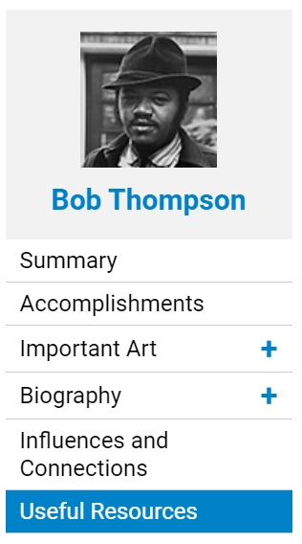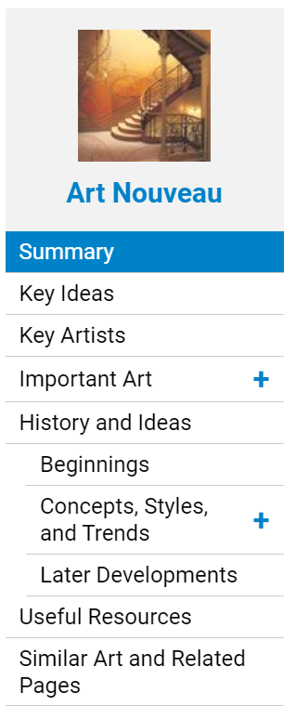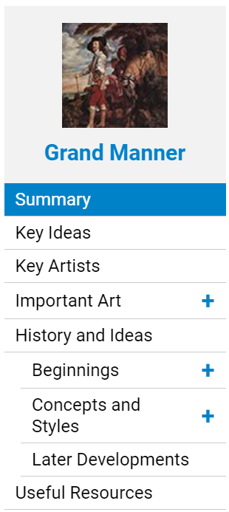
- Browse and/or search relevant Artist, Movement, and “Ideas” pages to identify key terms/categories as well as in-depth timelines of important artworks and their cultural and art-historical contexts with reference to a variety of relevant sources.
- The Useful Resources sections have an “Articles” tab that can point you to great sources for cultural and critical context and responses
- Take notes on subject-specific language used in connection with your selected artists, works, and connecting theme, idea, subject, or style
CITE
Scroll to the “Do more” section at the bottom of article page and click “Cite article”

Copy the comprehensive citation information in the “Cite this Page” pop-up:
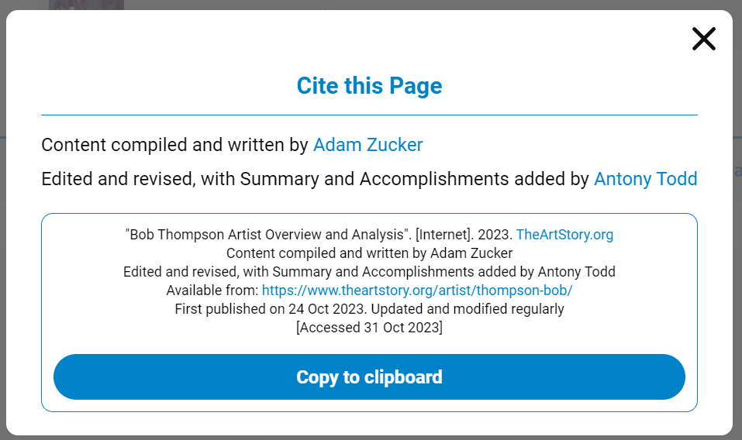
Paste the citation into your notes and/or “References” doc:
"Bob Thompson Artist Overview and Analysis". [Internet]. 2023. TheArtStory.org
Content compiled and written by Adam Zucker
Edited and revised, with Summary and Accomplishments added by Antony Todd
Available from: https://www.theartstory.org/artist/thompson-bob/
First published on 24 Oct 2023. Updated and modified regularly
[Accessed 31 Oct 2023]

Now modify the citation to fit MLA citation style:
Zucker, Adam, with Anthony Todd. “Bob Thompson Artist Overview and Analysis.” TheArtStory.org, 24 Oct 2023. www.theartstory.org/artist/thompson-bob/. Accessed 31 Oct 2023.
Last name, First name. “Title of Page.” Website, Date published. URL. Accessed date.

Scholar.Google.com
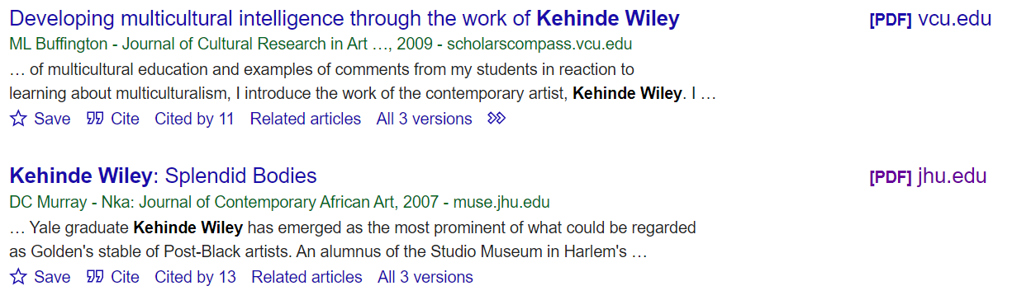
Look for the [PDF] links in the right column by your search results. Click the link to view and download the PDF of the article.
You can start by searching just the artist and title of artwork. What patterns do you notice in the results? Are there specific aspects of the artist’s process, style, tradition, or message that spark your interest for further research?
Look up unfamiliar and subject-specific terms in the Tate’s Art Terms list.
Types of sources:

- Exhibition catalogs
For example: Wendy Red Star: A Scratch on the Earth
Search The Met’s collection of digitized Exhibition Catalogs

- Books on art, artists, and/or critical theory
For example: https://read.dukeupress.edu/books/book/3172/Dissident-PracticesBrazilian-Women-Artists-1960s
Sample citation:
Calirman, Claudia. Dissident Practices: Brazilian Women Artists, 1960s–2020s. Duke UP, 2023.

- Textbooks
For example: IB Visual Arts Online Course Book: Oxford IB Diploma Programme

- Scholarly essays
For example:
https://www.e-flux.com/journal/49/59999/world-history-and-earth-art/

- Articles
For example: https://www.artforum.com/features/murtaza-vali-on-the-art-of-pacita-abad-252743/

- Art criticism and reviews
For example: https://www.vulture.com/article/jerry-saltz-moma-refik-anadol-unsupervised.html
Saltz, Jerry. “Moma’s Glorified Lava Lamp.” Vulture, 22 Feb. 2023, www.vulture.com/article/jerry-saltz-moma-refik-anadol-unsupervised.html.

- Artist Statements (for contemporary artists, often on artist website or in exhibition catalog)

- Museum websites
For example: https://www.menil.org/exhibitions/261-works-by-cy-twombly

Getty Research Portal - Getty Research Institute's collection of digitized art history texts.

The Met's Heilbrunn Timeline of Art History - reference for art historical context
“The Timeline of Art History presents the Met’s collection via a chronological, geographical, and thematic exploration of global art history. Targeted at students and scholars of art history, it is an invaluable reference, research, and teaching tool. Authored by the Met’s experts—predominantly made up of curators but also of conservators, scientists, and educators—the Timeline comprises 300 timelines, 930 essays, close to 7,000 objects, and a robust index, and is regularly updated and enriched to provide new scholarship and insights on the collection.”
Britannica Online Library Edition - reference for art historical context

Visit this Purdue OWL web page and scroll down to the "Painting, Sculpture, or Photograph" section for guidance on citing the high-quality images you use in your paper.

Recommended websites for finding high-quality images of artworks:
- National Gallery of Art, open access images
- Google Arts and Culture
- The Metropolitan Museum of Art
- Digital Public Library of America
- Europeana
Rice University Library Guide to Art History, selected Library & Museum Websites
Wake Forest Library guide for Art HistoryResearch Resources: Finding Images and Websites

Citing Images of Artworks  (in slides)  Embed image in slide:  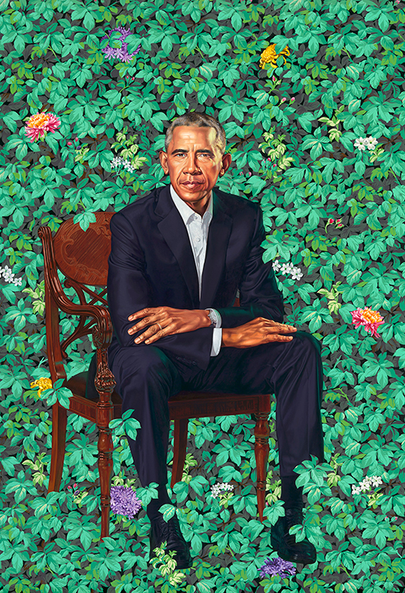  (Wiley, President Barack Obama) | MLA Citing Images of Artworks  Reference Slide  Wiley, Kehinde. President Barack Obama. 2018, National Portrait Gallery, Washington, D.C., npg.si.edu/Barack_Obama. Accessed 18 Oct 2023.  Artist's Last Name, First Name. Title of Artwork. Date Artwork Created, Name of Institution or Private Collection Housing Artwork, City Where it is Housed. URL. Accessed date.
Researching with Academic Databases
*Every time you find an academic article you might use, DOWNLOAD AND SAVE IT IN A GOOGLE DRIVE FOLDER TITLED
“IB Visual Arts CS” or “IB Visual Arts Comparative Study”

🏪Access Academic Databases and Ebooks through
the Houston Public Library Website

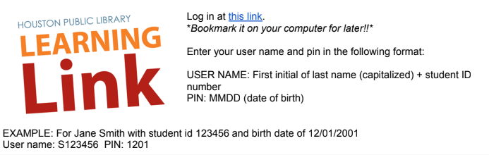

Access academic databases through Houston Public Library using the login instructions above.

Access databases HPL subscribes to and search for sources at houstonlibrary.org/az.php.



Once you’re logged into your library account, select A-Z Databases from the Research drop-down menu.
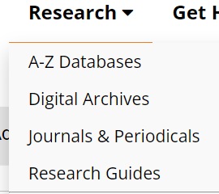
Under G you’ll find Gale Academic OneFile:
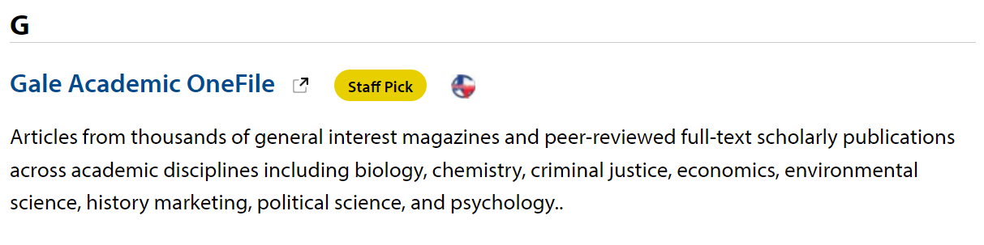



Access ProQuest directly at ProQuest.com. Click Log in through your library:

Choose Open Athens:


Search “Houston Public Library” and choose it from the drop-down menu:


Use your same login to sign in with your Houston Public Library account:


When you’re signed in, you’ll see Access provided by Houston Public Library at the top of the webpage:


ORGANIZING YOUR RESEARCH BY ARTWORK

Research notes based on IB suggested structure

[paste image of artwork and full citation here]
Artist's Last Name, First Name. Title of Artwork. Date Artwork Created, Name of Institution or Private Collection Housing Artwork, City Where it is Housed. URL. Accessed date.
- identification of the cultural contexts of the selected pieces

- identification and analysis of the formal qualities of the selected pieces (elements such as shape/ form, space, tone, colour, line, texture and principles such as balance, rhythm, proportion, emphasis, pattern, variety)

- analysis and understanding of the function and purpose of the selected pieces (such as the meanings of motifs, signs and symbols used in the work)

- analysis and evaluation of the material, conceptual and cultural significance of the pieces and the cultural contexts in which they were created.

Paste full references for all sources included in the table here. Use parenthetical citations throughout the table, with the author’s last name and page number if applicable (Lastname #). Purdue OWL here

Using McFee’s (1978) Conceptual Framework
(From collection of IBVA visual organizers in this PDF.)

[paste image of artwork and full citation here]
Artist's Last Name, First Name. Title of Artwork. Date Artwork Created, Name of Institution or Private Collection Housing Artwork, City Where it is Housed. URL. Accessed date.

Audience’s World → | Audience → | ARTWORK | ← Artist | ← Artist's World
The audience’s world is a context in which events of significance occur. Events of significance need to be researched as they impact the way artworks are valued and understood. The collective experience of a particular age or place can also be described as the audience’s world as well as a place for the existence of cultural beliefs, values, religions, rituals, ideas and concepts that also impact the way artworks are understood. | The audience can comprise discreet individuals and collectives who bring different experiences of the world to their understanding of an artwork.  An audience can be contemporary to the time and place the work was created in, or from outside the same time and place.  An audience can be informed or uninformed. | The artwork is considered as a sole entity. It is identified by its creator’s name, title, medium and size. The formal qualities, mood, any signs and symbols used to convey meaning are considered. | The artist is the author of the work. The artist’s practice can be informed by any association with styles, schools or movements.  The technical processes and intent of the artist are considered. | The artist’s world is a context in which events of significance occur.  Events of significance for the artist can be the collective experience of a particular age or place but may also be deeply personal experiences.  Events of significance need to be researched as they impact the way artworks are created. The cultural beliefs, values, religions, rituals, ideas and concepts also impact the way an artist creates.
Paste full references for all sources included in the table here. Use parenthetical citations throughout the table, with the author’s last name and page number if applicable (Lastname #). Purdue OWL here

Research notes using Feldman’s art criticism model

[paste image of artwork and full citation here]
Artist's Last Name, First Name. Title of Artwork. Date Artwork Created, Name of Institution or Private Collection Housing Artwork, City Where it is Housed. URL. Accessed date.
Paste full references for all sources included in the table here. Use parenthetical citations with the author’s last name and page number if applicable (Lastname #).
Description
Analysis
Interpretation
Judgment
Paste full references for all sources included in the table here. Use parenthetical citations throughout the table, with the author’s last name and page number if applicable (Lastname #). Purdue OWL here

Research notes using IB Grading Criteria

[paste image of artwork and full citation here]
Artist's Last Name, First Name. Title of Artwork. Date Artwork Created, Name of Institution or Private Collection Housing Artwork, City Where it is Housed. URL. Accessed date.

A | Identification and analysis of formal qualities
B | Analysis and understanding of function and purpose
C | Analysis and evaluation of cultural significance
D | Making comparisons and connections
E | Presentation of subject-specific language
F | Making connections to own art-making practice
Paste full references for all sources included in the table here. Use parenthetical citations throughout the table, with the author’s last name and page number if applicable (Lastname #). Purdue OWL here

Use the tables below for ideas of Visual Art and Art Historical questions and features to consider in your comparative study.
You can also use these questions to identify search terms for finding sources.

Writing in Art History: Comparison Essays
UNC Writing Center

Pre-writing: observations and note-taking
You can begin this kind of essay with the same process of observations and note-taking outlined above for formal analysis essays. Consider using the same questions and categories to get yourself started.
Here are some questions you might ask:
- What techniques were used to create these objects?
- How does the use of color in these two works compare? Is it similar or different?
- What can you say about the composition of the sculpture? How does the artist treat certain formal elements, for example geometry? How do these elements compare to and contrast with those found in the painting?
- How do these works represent their subjects? Are they naturalistic or abstract? How do these artists create these effects?
Why do these similarities and differences matter?

Comparing and Contrasting from UNC Writing Center

Here are some general questions about different types of things you might have to compare. These are by no means complete or definitive lists; they’re just here to give you some ideas—you can generate your own questions for these and other types of comparison. You may want to begin by using the questions reporters traditionally ask: Who? What? Where? When? Why? How? If you’re talking about objects, you might also consider general properties like size, shape, color, sound, weight, taste, texture, smell, number, duration, and location.

Two historical periods or events

When did they occur—do you know the date(s) and duration? What happened or changed during each? Why are they significant?

What kinds of work did people do? What kinds of relationships did they have? What did they value?

What kinds of governments were there? Who were important people involved?

What caused events in these periods, and what consequences did they have later on?

Two ideas or theories

What are they about?

Did they originate at some particular time?

Who created them? Who uses or defends them?

What is the central focus, claim, or goal of each? What conclusions do they offer?

How are they applied to situations/people/things/etc.?

Which seems more plausible to you, and why? How broad is their scope?

What kind of evidence is usually offered for them?

Two pieces of writing or art

What are their titles? What do they describe or depict?

What is their tone or mood? What is their form?

Who created them? When were they created? Why do you think they were created as they were? What themes do they address?

Do you think one is of higher quality or greater merit than the other(s)—and if so, why?

For writing: what plot, characterization, setting, theme, tone, and type of narration are used?

Two people

Where are they from? How old are they? What is the gender, race, class, etc. of each?

What, if anything, are they known for? Do they have any relationship to each other?

What are they like? What did/do they do? What do they believe? Why are they interesting?

What stands out most about each of them?

Deciding what to focus on

By now you have probably generated a huge list of similarities and differences—congratulations! Next you must decide which of them are interesting, important, and relevant enough to be included in your paper. Ask yourself these questions:

What’s relevant to the assignment?

What’s relevant to the course?

What’s interesting and informative?

What matters to the argument you are going to make?

What’s basic or central (and needs to be mentioned even if obvious)?

Overall, what’s more important—the similarities or the differences?

Writing in Art History: Visual Analysis
UNC Writing Center
Composition
- How are all the different components of the object or image arranged?
- What do you notice first, and why?
- How does the work lead you through the composition?
- Is the composition symmetrical or asymmetrical? If asymmetrical, is the composition balanced in some way?
Technique
- Was the object or image built up by adding material, or was it created by carving away material?
- What kind of paint or finish was added to the material?
- Does the technique seem methodical or spontaneous? How so?
Color
- What colors are present? How are the colors arranged?
- Do the colors appear saturated or muted?
- Are the colors warm or cool?
- Do the colors complement one another or does one clash with the others?
Texture
- Does the material have a physical texture? How would you describe it? What creates the texture?
- Does the material simulate or imply texture in some way, even if on a flat surface? How so?
Line
- Are contour lines present?
- How would you describe the quality and direction of the lines (for example, heavy or thin, rough or smooth, short or long, horizontal, vertical, or diagonal)?
- How do lines create movement or a sense of direction?
- What are any figures depicted looking at or gesturing towards?
Scale
- How large is the object overall? Is the size typical for this kind of object or for this kind of subject?
- Are some components of the object larger than others?
- For two-dimensional materials, how does scale affect the relationship between the objects represented? Are some objects smaller or larger than you might expect?
- For two-dimensional materials, how is space suggested? Do forms overlap, or do they seem to stack on top of each other?
Material
- What materials is the object or image made of?
- How are those materials distributed (if there’s more than one)?
- What effects do the juxtaposition of materials create?
Shape
- Are the figures naturalistic or abstract?
- Are the forms geometric or organic?
- How do shapes repeat throughout the composition?
- For figures, are the proportions distorted, elongated, or idealized?
- What kinds of shapes are formed from the negative space?

Guidelines for the Analysis of Art
From UALR School of Art and Design
In any analysis, keep in mind: HOW and WHY is this a significant work of art?

Part I – General Information
- In many cases, this information can be found on a label or in a gallery guidebook. An artist’s statement may be available in the gallery. If so, indicate in your text or by a footnote or endnote to your paper where you got the information.
- Subject Matter (Who or What is Represented?)
- Artist or Architect (What person or group made it? Often this is not known. If there is a name, refer to this person as the artist or architect, not “author.” Refer to this person by their last name, not familiarly by their first name.)
- Date (When was it made? Is it a copy of something older? Was it made before or after other similar works?)
- Provenance (Where was it made? For whom? Is it typical of the art of a geographical area?)
- Location (Where is the work of art now? Where was it originally located? Does the viewer look up at it, or down at it? If it is not in its original location, does the viewer see it as the artist intended? Can it be seen on all sides, or just on one?)
- Technique and Medium (What materials is it made of? How was it executed? How big or small is it?)

Part II – Brief Description
In a few sentences describe the work. What does it look like? Is it a representation of something? Tell what is shown. Is it an abstraction of something? Tell what the subject is and what aspects are emphasized. Is it a non-objective work? Tell what elements are dominant. This section is not an analysis of the work yet, though some terms used in Part III might be used here. This section is primarily a few sentences to give the reader a sense of what the work looks like.

Part III – Form
This is the key part of your paper. It should be the longest section of the paper. Be sure and think about whether the work of art selected is a two-dimensional or three-dimensional work.

Art Elements
- Line (straight, curved, angular, flowing, horizontal, vertical, diagonal, contour, thick, thin, implied etc.)
- Shape (what shapes are created and how)
- Light and Value (source, flat, strong, contrasting, even, values, emphasis, shadows)
- Color (primary, secondary, mixed, complimentary, warm, cool, decorative, values)
- Texture and Pattern (real, implied, repeating)
- Space (depth, overlapping, kinds of perspective)
- Time and Motion

Principles of Design
- Unity and Variety
- Balance (symmetry, asymmetry)
- Emphasis and Subordination
- Scale and Proportion (weight, how objects or figures relate to each other and the setting)
- Mass/Volume (three-dimensional art)
- Rhythm
- Function/Setting (architecture)
- Interior/Exterior Relationship (architecture)

